***LIBRARY MANAGEMENT SYSTEM***

* Class diagram

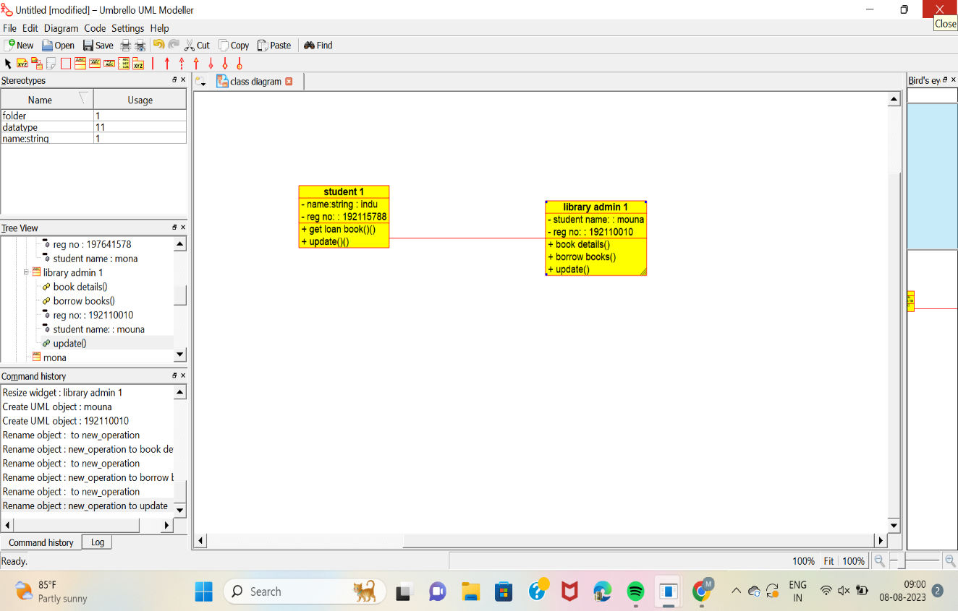

* Use case diagram

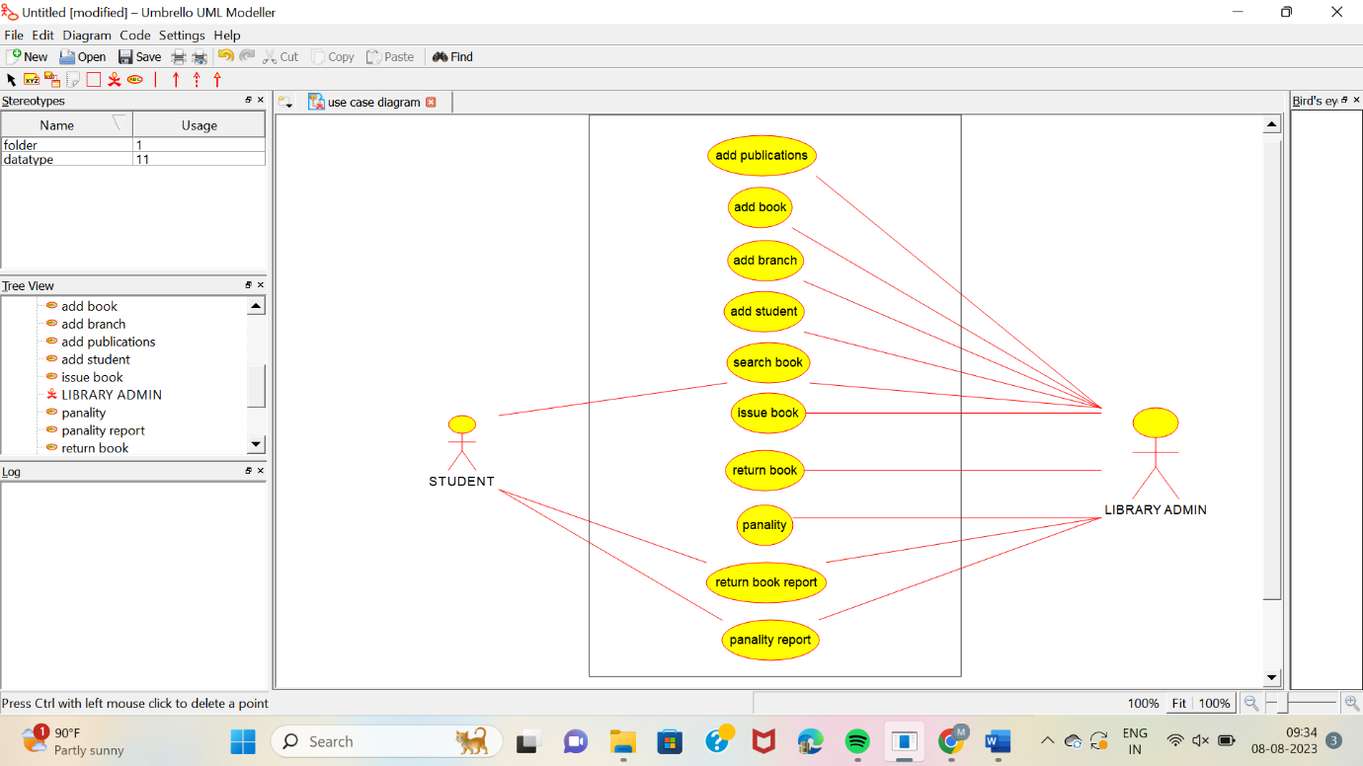

* Sequence diagram

